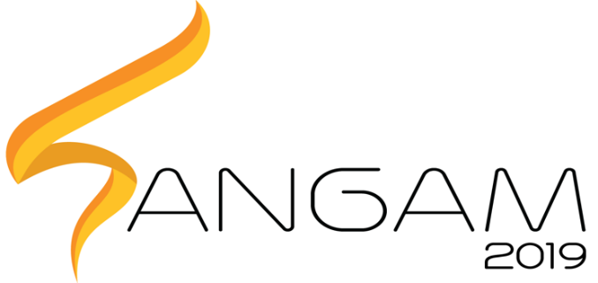  
 PRAGYAN HARDWARE HACKATHON

**SPEAR – Soft Pneumatic Electromyography (EMG)**

**Assisted Rehabilitation**

* **Key resources:** Intellectual: Any patents etc that arise from SPEAR.
* **Value propositions:** SPEAR offers its customers cost effective, one-time investment solution rather than conventional physiotherapy process which consumes both money and time to a large extent.
* **Cost structure:**

Orthosis - 6000

EMG Sensors - 5000

McKibben muscles - 400

Compressor and Tank - 1600

Pneumatic Valves - 2500

Miscellaneous (Tubes, connectors, etc.) - 500

Total - 16000

* **Future work:** Since it is a niche product, SPEAR requires the funding and support of a major healthcare corporation to survive. We plan to present perfect the design and approach specialists from the healthcare industry to acquire funding for production, marketing and distribution of SPEAR.